SIMPLE MACHINES
What Is a Simple Machine?
A mechanical device that changes the direction or magnitude of a force is known as a simple machine. In general terms, they are defined as simple mechanisms that use leverage or mechanical advantage to multiply force. Simple machines have few or no moving parts to modify motion and force. Let us learn more about the six simple machines in the following few sections.
The Inclined Plane
An inclined plane is a sloping plane used to raise heavy bodies. Inclined planes make it easier to lift objects to greater heights. There are two ways to raise an object: it can be either raised by lifting it straight up or by pushing it diagonally up.
Lifting an object straight up moves the object in the shortest distance, but a more significant force must be exerted. Using an inclined plane to lift objects requires a smaller force but must be exerted over a long distance. A few everyday examples of inclined planes include sidewalk ramps, highway access ramps, inclined conveyor belts, and switchback roads.
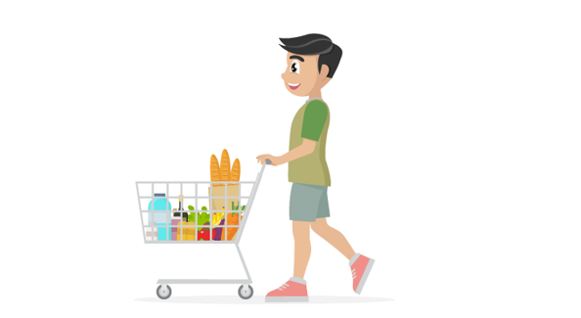

Wheel and Axle
Wheel and axle make work easier by moving objects across distances. The wheel and axle greatly reduce the friction involved in moving an object. The wheel (round ends) turns with the axle (or cylindrical post), causing movement. The wheel is one of the most significant inventions in the history of the world. Before the invention of wheels, the amount of load and the distance through which we could carry the load over land was limited. It is easier to roll a 2000-kilogram block of stone using logs placed underneath it than to push it.
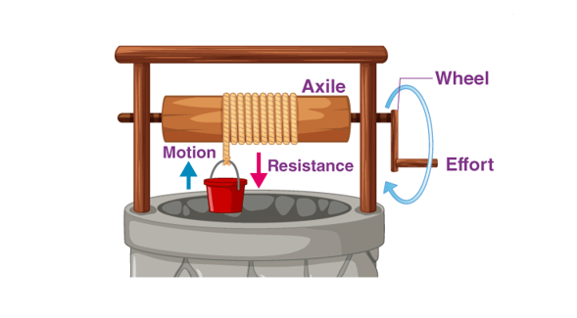

Pulley
Instead of an axle, a wheel could also rotate a rope, cord, or belt. The variation of the wheel and axle is the pulley. In a pulley, a cord wraps around a wheel. It is a simple machine that is used to change the direction of the force. When the wheel rotates, the cord can move in either direction. By attaching a hook to the cord, the wheel’s rotation can be used to raise or lower objects, making work easier. Various types of pulley help in making a variety of lifting and moving tasks easier. A pulley system is necessary to hoist a flag on a flag pole. A rope is attached to the pulley to raise and lower the flag more easily.
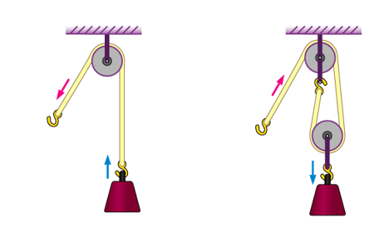
Lever
A lever is a tool that is used to pry objects loose. Levers are also used to lift objects. A lever has an arm that turns against a fulcrum. Exerting a force on one end of the pivot creates a force on the other end of the lever. The applied force is either increased or decreased based on the distance from the fulcrum to the load and from the fulcrum to the effort. A few examples of levers are the hammer that we used to pry nails loose and the kids’ favourite see-saw.
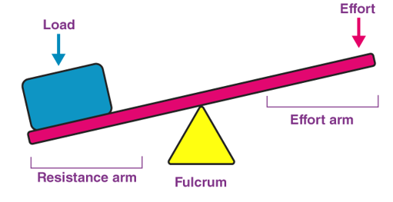

Screw
An inclined plane wrapped around a shaft is known as a screw. The two primary functions of a screw are to hold things together or to lift objects. The threading around the shaft in a screw makes it an efficient tool to hold things together. The threads grip the surrounding material like teeth, resulting in a secure hold. A few examples of screws include screw, bolt, clamp, spinning stool, and spiral staircase. A car jack is an example of a screw used to lift something.
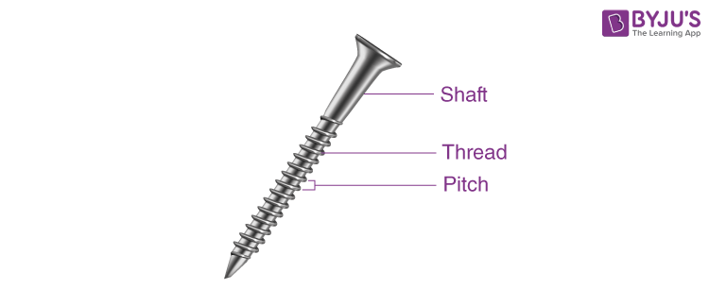
Wedge
A wedge is a simple machine that is used to break apart substances by applying force. A nail is a common example of a wedge. In a nail, the force is applied to the wide head area. This applied force is concentrated in a small point area where the force is exerted. At this point, the force is magnified and enables the force to pierce through objects. As the nail sinks into the object, the wedge shape at the point of the nail moves forward and forces the object apart.
